# How to commit your code-

1. Go to eclipse project🡪Right Click🡪Team🡪Commit

2.you will find staged and unstaged changes , change the structure to tree format,if not.

3. put only changed files in staged changes,other in unstaged changes.

4.click on staged(changed) files to check the SONAR issues,compare.

5.write commit message

5.if no issue,commit

6.Go to Jenkins, search your service go your branch,build now.

# Steps to Deploy in PRE

1. Make changes in your code, go to to gitlab, create merge request by clicking merge request on the side bar of UK gitLab.

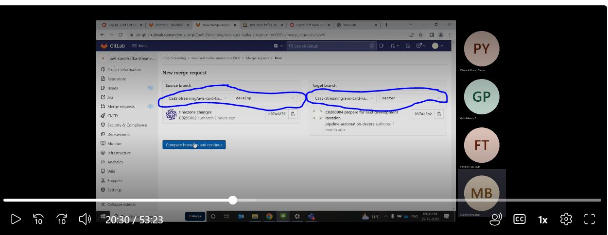

2. Go to release, build with parameter.you need to put version

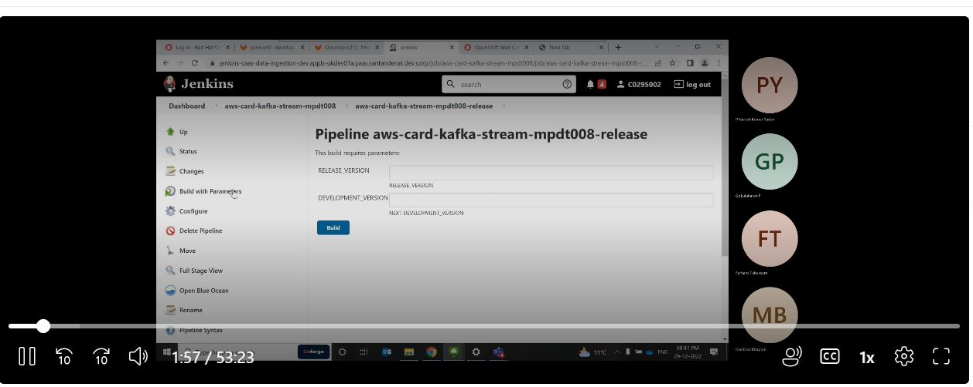

3. Go to pom.xml ,check version🡪 version of application

Master branch also,must have the same version.

4. Development Version🡪it is the next version (0.0.5 snapshot)- 🡪 (0.0.6 snapshot.)

Release Version 🡪0.0.5

5.click build. This is creating release tag ,with tagversion ,if some one asks release tag. you need to go to tag and share the url. Devops engineer will deploy your version to PRE-OPENSHIFT.We only do creation of release tag.

Commit krte h to dev me save ho jata ,fir usko master me merge kr dete h ,fir hmlog relase tag create krte h fir ,devops team openshift me deploy krti h.

# How to create merge request